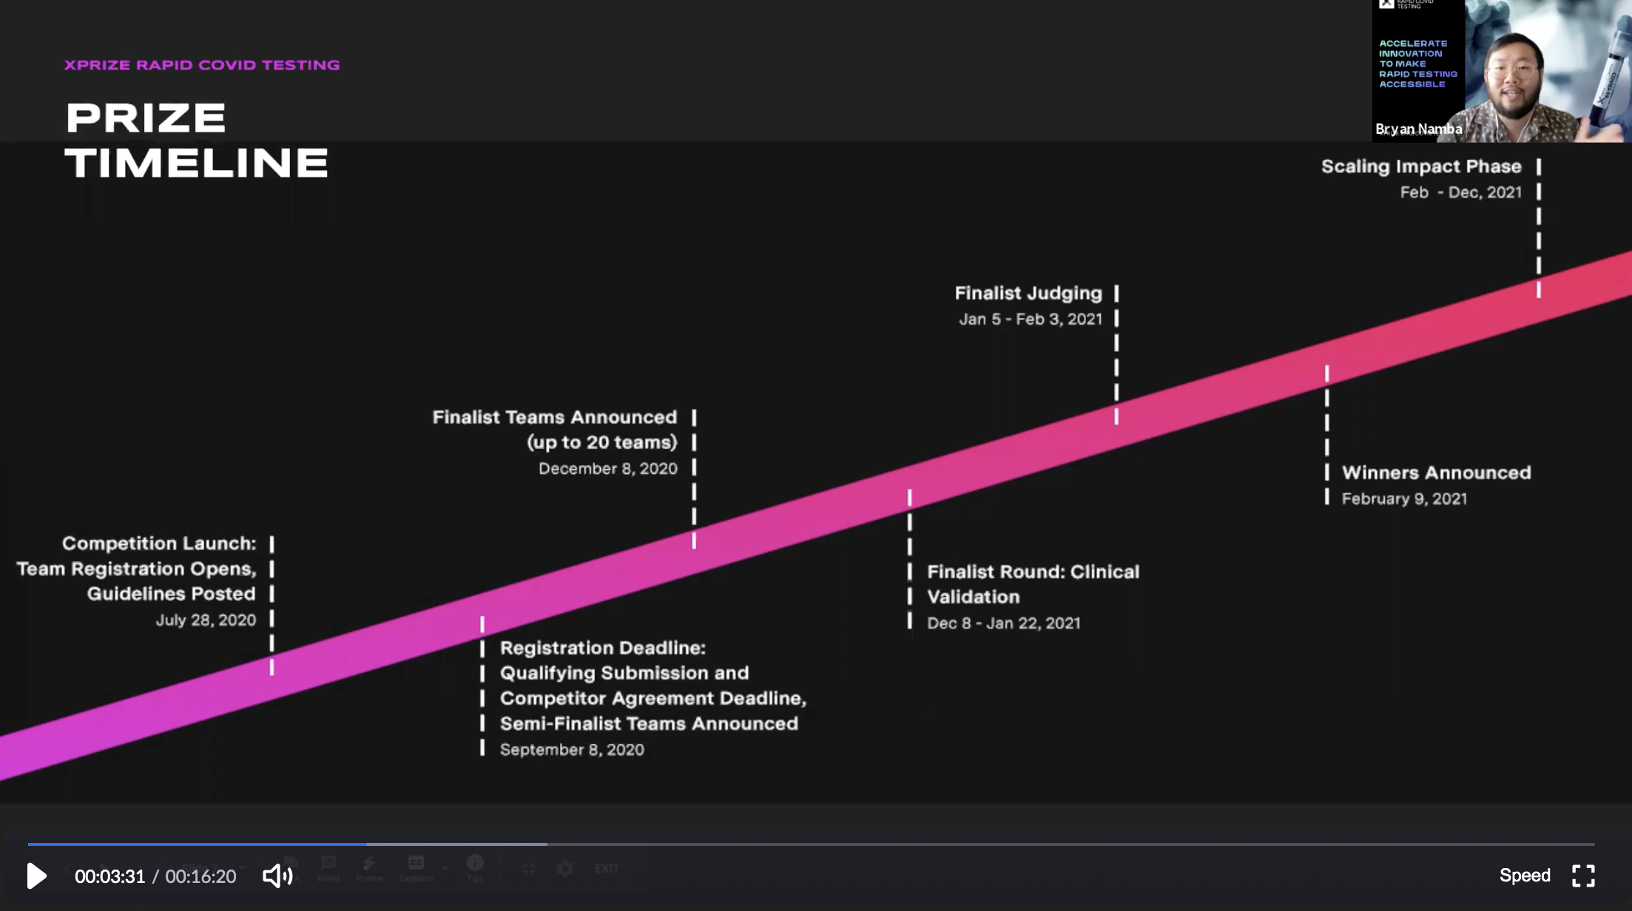
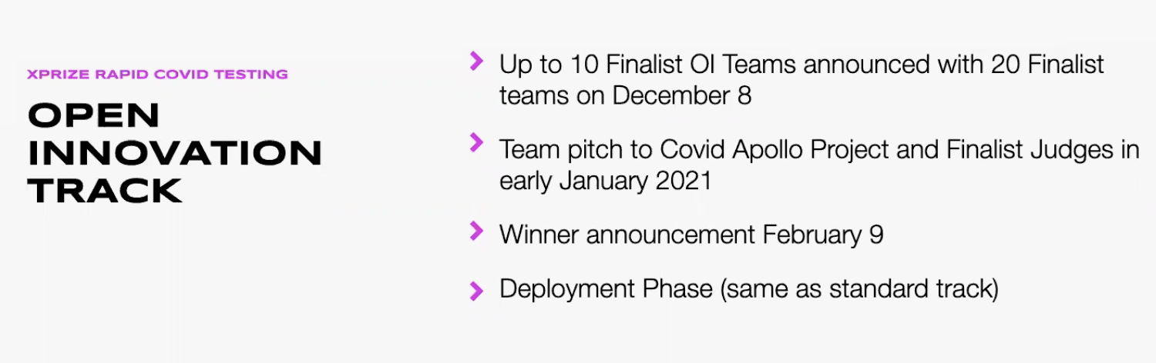

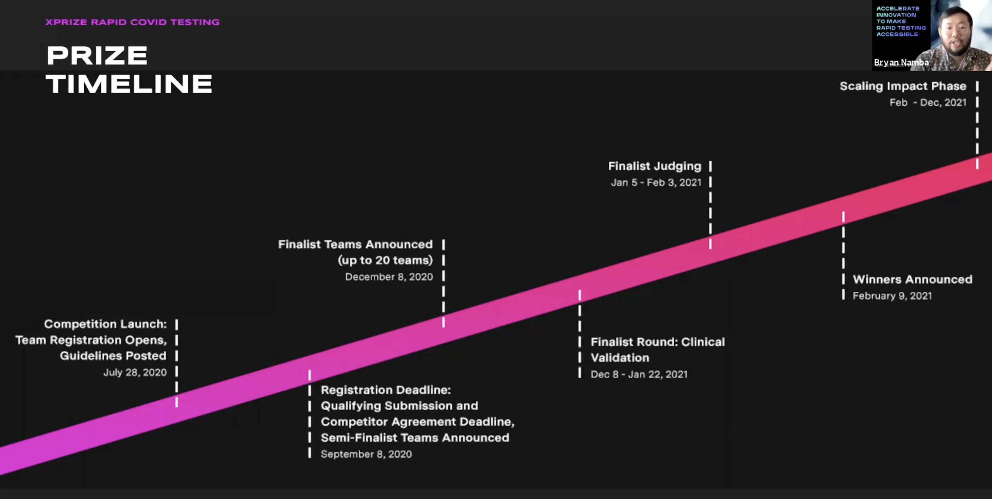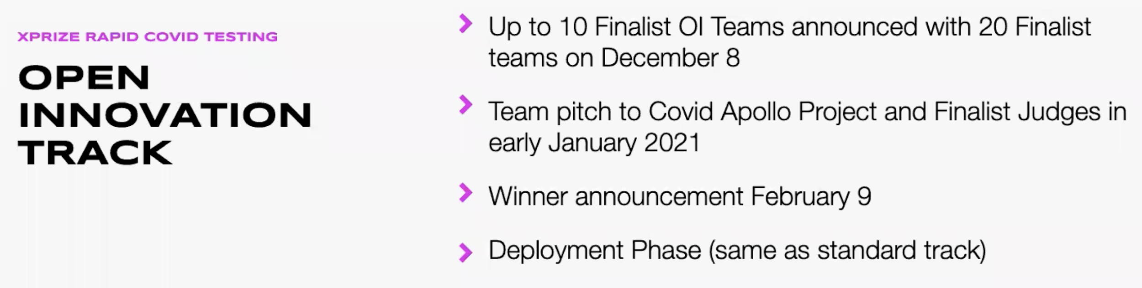
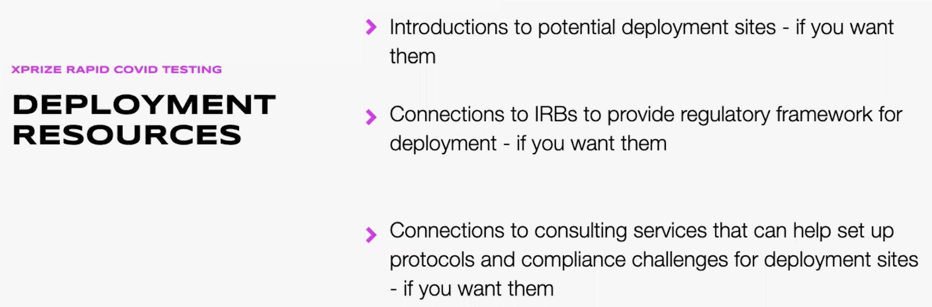

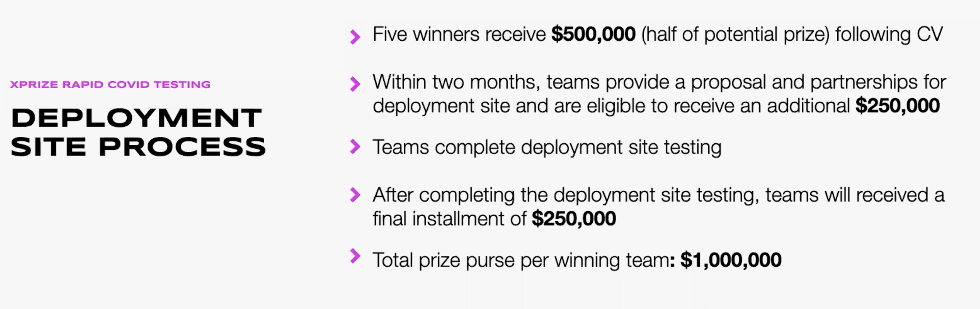

Guidelines (PDF)
These Competition Guidelines describe the objectives that govern XPRIZE Covid Testing.

Team Registration Fee (PDF)

Competitor Agreement (PDF)
A legal and binding document that details the responsibilities of competitors for the prize.

In order to be eligible to advance as a top 200 semifinalist team, the competitor agreement must be completed by the registration deadline. The deadline to register is August 31, 2020 18:59:59 UTC.

Competitor Agreement Exhibit E: Team Member Release, Waiver and Confidentiality Agreement (PDF)
In addition to the Competitor Agreement signed by the Team Leader, all Team members are required to acknowledge the terms of the Competitor Agreement by completing the Team Member Release, Waiver and Confidentiality Agreement (Exhibit E).

To complete this activity, each Team Member, including the Team Leader, should complete Exhibit E Team Member Release, Waiver, and Confidentiality Agreement. Please download the corresponding document under the Resources tab, complete all fields, and upload the completed document to this activity.

Whenever possible, individual team member forms should be compiled into one file before being uploaded to POP.

